**A Novel Approach to Provide Protection for**

**Women by using Smart Security Device**

**ABSTRACT**

In today’s world women are less secure and have many issues regarding their security purpose. They have to undergo among various difficult situations and have to prove themselves every time in all critical conditions. So, for their security and safety purpose government has provided security through rules and regulation to the society. Although there are many existing systems for security purpose need of advanced smart security system is increased. In order to overcome such problems smart security system for women is implemented. This paper describes about safe and secured electronic system for women which comprises of an Arduino controller and sensors such as temperature LM35, flex sensor, MEMS accelerometer, pulse rate sensor, sound sensor. A buzzer, LCD, GSM and GPS are used in this project. When the women is in threat, the device senses the body parameters like heartbeat rate, change in temperature, the movement of victim by flex sensor, MEMS accelerometer and the voice of the victim is sensed by sound sensor. When the sensor crosses the threshold limit the device gets activated and traces the location of the victim using the GPS module. By using the GSM module the victim’s location is sent to the registered contact number.

**INTRODUCTION**

Safety is the most wanted power for everyone in today’s world. Technology is the best way to achieve it. That’s the reason to develop this project that can act as a rescue device and protect at the time of danger. The motivation behind this project is an attempt to focus on a security system that is designed merely to serve the purpose of providing security to women so that they never feel helpless while facing such social challenges. An advanced system can be built that can detect the location and health condition of person that will enable us to take action accordingly based on electronic gadgets like GPS receiver, GSM, pulse rate sensor, flex sensor, MEMS accelerometer, body temperature sensor. We can make use of number of sensors to precisely detect the real time situation of the women in critical abusive situations. The heartbeat of a person in such situations is normally higher which helps make decisions to detect the abnormal motion of the women while she is victimized.

**EXISTING SYSTEMS**

In Women and children based security system victim has to press the emergency button, but in emergency conditions pressing the button is may not be possible. Using Smart Phone, the child cannot send its location by itself. The parent of that child has to send the message to the child's system to know their location. In "Mobile Tracking Application for Locating Friends”, a tracking application software must be installed in the mobile phone and the friends must be previously registered in the friends group of application. To track their friends mobile phones are needed in both sides. In an Intelligent System based on RFID and GPS Technologies for Women Safety has some limitations in terms of cost, signal interferences and also the information access to invalid and unauthenticated users. The main drawback of these applications and services is that the initial action has to be triggered by the victim which often in situation like these doesn’t happen. So the emphasis is to build a solution that works autonomously in situations encountered. This paper presents new method to provide protection for women or children by ringing the buzzer and send the location to the nearby police station where the victim is present.

**EXISTING SYSTEM DISADVANTAGE**

* Mobile based GPS not much accurate.
* It will have more cost.
* The main drawback of these applications and services is that the initial action has to be triggered by the victim which often in situation like these doesn’t happen.
* So it cannot emphasis is to build a solution that works autonomously in situations encountered.

**PROPOSED SYSTEM**

The architecture of proposed system consists of Arduino controller. As a main source and it receives input signals from the sensors, where thereby the sensors receives the input signals from a human who is in threat or in danger or in abnormal situations. The sensors described in the architecture are temperature LM35 sensor, MEMS accelerometer, heartbeat sensor, flex sensor, sound sensor. To display the body parameters[6] of the women(victim)in a dangerous situation an output is used in this project LCD 16*2display is used, also buzzer is used and GSM is used to send the alert message to the registered contact number where as GPS is used to track the location of that person(women). The principle behind this is to detect body parameter signals from the respective sensors which are in contact with the women who are in threat condition and hence after detecting signals, the sensor transmits the output electrical signals to the controller. The Arduino receives the signal from the sensor as an analog input signal and hence it generates the output parameters of each sensor and displays it on the LCD display. The sensors used in the proposed system are flex sensor, temperature sensor, MEMS accelerometer, sound sensor, pulse rate sensor. Each sensor is used to detect signals of human (women) who is in abnormal situations. If values of any sensor signal crosses the threshold limit indicating that the women is in threat and according to victim condition, when 4 sensors out of 5 sensors crosses the threshold limit the buzzer is activated. Hence the GPS transmits the location to the Arduino and then the Arduino transmits the signal to the GSM. Finally the alert message “I am in danger” along with the latitudinal and longitudinal location is send to the registered contact number. Thus activation of sensor and buzzer traces the location of victim using GPS and with the help of GSM used sends the message of location to the corresponding contacts with a 10secs delay.

**PROPOSED ADVANTAGE**

* Accuracy of location is much better than smart mobile.
* Fast alert sending to the person.
* Autonomously Sms will send.
* Fast response time.
* Health Monitoring will be available.

**BLOCK DIAGRAM**

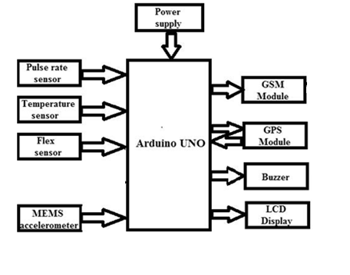

**HARDWARE REQUIREMENT**

* Arduino
* Pulse sensor
* Temperature sensor
* Flux sensor
* MEMS sensor
* LCD
* Buzzer
* GPS
* GSM

**SOFTWARE REQUIREMENT**

* ARDUINO